**4. DC BO MOTOR**

**4.1 WHAT IS BO MOTOR?**

BO (Battery Operated) light weight DC geared motor which gives good torque and rpm at lower voltages. This motor can run at approximately 150 RPM when driven by a single Li-Ion cell. Dc motor converts electrical energy into mechanical energy. In any DC motor, RPM and Torque is inversely proportional. In all DC gear motor PWM [Pulse Width modulation](https://www.androiderode.com/pwm-pulse-width-modulation/) circuit is used.

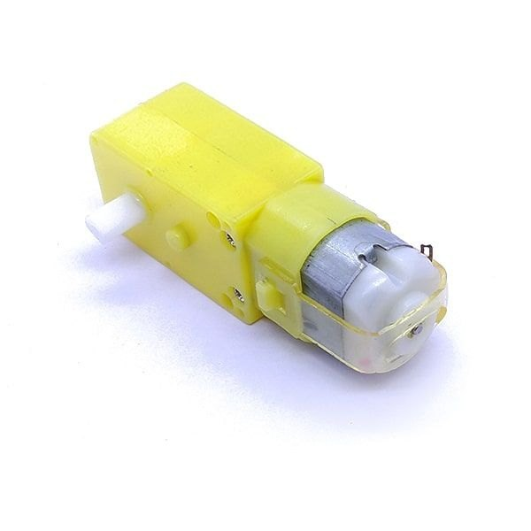

**4.2 WHY DC GEAR MOTOR USED IN ROBOT MOTOR CONTROL CIRCUIT?**

DC MOTOR concept is where gears reduce the speed of the vehicle but increase its torque is known as gear reduction. In DC motor is assembled with multiple gear setup. Speed of motor is counted in terms of rotations of the soft per minute is called RPM. RPM means Revolution Per Minute. The setup assemble helps to increase the torque and reduce the motor speed. For all micro-controller-based Robots, this type of DC motor can be used.

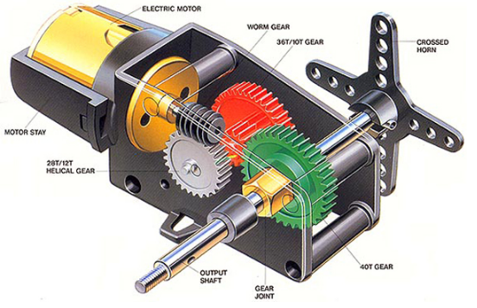

For both-way motion like Clockwise and Anticlockwise of one DC Motor, an H Bridge circuit is needed.  
For the both-way motion of 2 motors, a Dual H-Bridge IC named L293D can be used.

The Motor Driver is a module for motors that allows you to control the working speed and direction of two motors simultaneously. L293D is a 16 Pin Motor Driver IC. This is designed to provide bidirectional drive currents at voltages from 5 V to 36 V.

**4.3 HOW TO SELECT DC MOTOR**

For [light weight robot](https://www.androiderode.com/diy-line-follow-robot/) required low power plastic gear DC motor.300 RPM low cost single shaft straight DC gear motor. Most suitable for[light weight robot.](https://www.androiderode.com/diy-line-follow-robot/)  
Motor runs smoothly for 2V to 12 VDC and gives wide range of RPM and Torque.

**4.3.1 Specifications**

* Model: RM0402
* Weight: 100gm
* RPM: 60 TO 300
* Voltage:2 DC to 12 VDC